Think about what we are doing in the lab.

Try to list 5 points. (**Newton 2nd Law**)

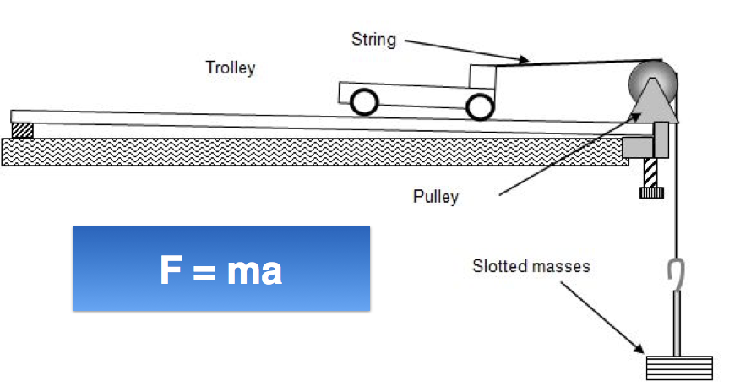

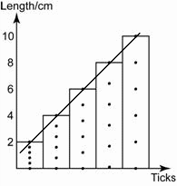

|  |  |
| --- | --- |
|  | **Why do we need lab session?** |
| 1 |  |
| 2 |  |
| 3 |  |
| 4 |  |
| 5 |  |

|  |  |
| --- | --- |
|  | **What are the requirements that students need to accomplish in lab session?** |
| 1 |  |
| 2 |  |
| 3 |  |
| 4 |  |
| 5 |  |

|  |  |
| --- | --- |
|  | **How can you prepare well for lab session?** |
| 1 |  |
| 2 |  |
| 3 |  |
| 4 |  |
| 5 |  |

Think about what we are doing in the lab.

Try to list 5 points. (**Electrolysis**)

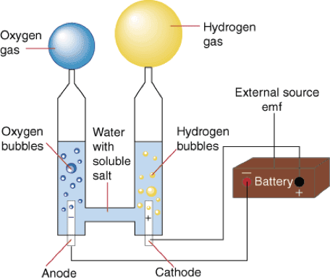

|  |  |
| --- | --- |
|  | **Why do we need lab session?** |
| 1 |  |
| 2 |  |
| 3 |  |
| 4 |  |
| 5 |  |

|  |  |
| --- | --- |
|  | **What are the requirements that students need to accomplish in lab session?** |
| 1 |  |
| 2 |  |
| 3 |  |
| 4 |  |
| 5 |  |

|  |  |
| --- | --- |
|  | **How can you prepare well for lab session?** |
| 1 |  |
| 2 |  |
| 3 |  |
| 4 |  |
| 5 |  |

Think about what we are doing in the lab.

Try to list 5 points. (**Photosynthesis**)

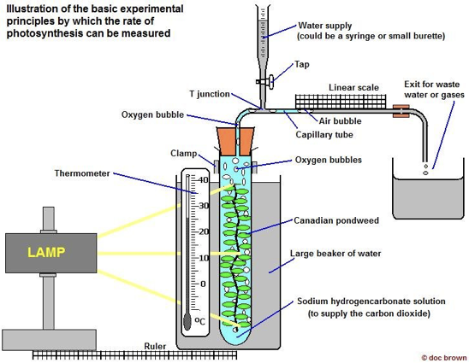

|  |  |
| --- | --- |
|  | **Why do we need lab session?** |
| 1 |  |
| 2 |  |
| 3 |  |
| 4 |  |
| 5 |  |

|  |  |
| --- | --- |
|  | **What are the requirements that students need to accomplish in lab session?** |
| 1 |  |
| 2 |  |
| 3 |  |
| 4 |  |
| 5 |  |

|  |  |
| --- | --- |
|  | **How can you prepare well for lab session?** |
| 1 |  |
| 2 |  |
| 3 |  |
| 4 |  |
| 5 |  |